

**MUTHAYAMMAL COLLEGE OF ARTS AND SCIENCE, RASIPURAM.**

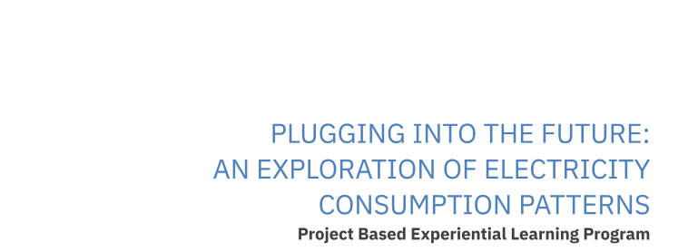

**PROJECT BY;**

**TEAM LEADER: LOGESH S (20UPH1408)**

TEAM MEMBERS: SRIDHAR R (20UPH1414)

ABHISHEK S ( 20UPH1403)

PRASANTH G (20UPH1410)



**Plugging into the Future: An Exploration of**

**Electricity Consumption Patterns**

India is the world's third-largest producer and third-largest consumer of electricity. The national electric grid in India has an installed capacity of 370.106 GW as of 31 March 2020. Renewable power plants, which also include large hydroelectric plants, constitute 35.86% of India's total installed capacity. During the fiscal year (FY) 2019–20, the total electricity generation in the country was 1,598 TWh, of which 1,383.5 TWh generated by utilities. The gross electricity consumption per capita in FY2019 was 1,208 kWh.

In 2015-16, electric energy consumption in agriculture was recorded as being the highest (17.89%) worldwide. The per capita electricity consumption is low compared to most other countries despite India having a low electricity tariff.

In light of the recent COVID-19 situation, when everyone has been under lockdown for the months of March to June the impacts of the lockdown on economic activities have been faced by every sector in a positive or a negative way.

The dataset is exhaustive in its demonstration of energy consumption state wise.

Analysing Electricity Consumption in India from Jan 2019 till 5th December 2020. This dataset contains a record of Electricity consumption in each states of India, here we are going to analyse State wise , Region wise and Overall Electricity consumption in India.

**Technical Architecture:**

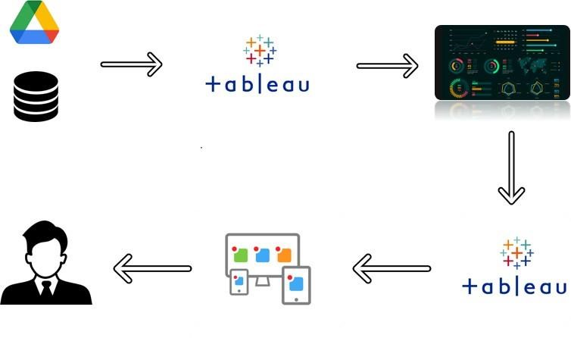

# Project Flow

To accomplish this, we have to complete all the activities listed below,

* Define Problem / Problem Understanding o Specify the business problem o Business requirements o Literature Survey o Social or Business Impact.
* Data Collection & Extraction from Database o Collect the dataset, o Storing Data in DB o Perform SQL Operations o Connect DB with Tableau
* Data Preparation o Prepare the Data for Visualization
* Data Visualizations o No of Unique Visualizations
* Dashboard o Responsive and Design of Dashboard
* Story o No of Scenes of Story
* Performance Testing o Amount of Data Rendered to DB ‘ o Utilization of Data Filters o No of Calculation Fields o No of Visualizations/ Graphs
* Web Integration o Dashboard and Story embed with UI With Flask
* Project Demonstration & Documentation o Record explanation Video for project end to end solution o Project Documentation-Step by step project development procedure

## Milestone 1: Define Problem / Problem Understanding

**Activity 1: Specify the business problem**

Refer Project Description

### Activity 2: Business requirements

The business requirements for analyzing analysis on electricity consumption in IndiaIdentify the current patterns of electricity consumption in different regions and sectors of India. This information can be used to identify areas where consumption is high and areas where it is low. Identify opportunities for improving energy efficiency and reducing consumption in different sectors and regions. This information can be used to develop policies and programs to promote energy efficiency. This information

can be used by government agencies, electricity providers, and investors to develop policies and make investment decisions that promote sustainable energy development and consumption in India.

### Activity 3: Literature Survey (Student Will Write)

A literature survey is a method of researching existing literature and studies related to a specific topic.The topic of electricity consumption in India is a well-researched area, with many studies having been conducted to understand consumption patterns and trends, as well as the impact of government policies and investment opportunities.A study by (Kumar et al., 2020) analyzed the electricity consumption patterns in India and identified the major contributors to the consumption. The study found that the residential sector was the largest consumer of electricity, followed by the commercial and industrial sectors.Another study by (Jain and Rathi, 2019) analyzed the impact of government policies on electricity consumption in India. The study found that policies promoting energy efficiency and renewable energy development have had a positive impact on reducing electricity consumption in India.

**Activity 4: Social or Business Impact.**

Social Impact: By providing access to electricity, the analysis can help to improve the quality of life for people living in areas without access to electricity, including providing access to lighting, heating, and cooling, and powering essential services such as hospitals and schools..

Business Model/Impact: By understanding consumption patterns and trends, the analysis can help businesses identify market opportunities and develop strategies to meet the growing demand for electricity in India.

## Milestone 2: Data Collection & Extraction from Database

Data collection is the process of gathering and measuring information on variables of interest, in an established systematic fashion that enables one to answer stated research questions, test hypotheses, and evaluate outcomes and generate insights from the data.

### Activity 1: Collect the dataset

Please use the link to download the dataset:

<https://drive.google.com/file/d/1JxIkHNwXxjFztKq7ad0_KtkukCqTckNy/view?usp=sharing>

**Activity 1.1: Understand the data**

In Dataset Consumption.csv data is in the form of a time series for a period of 24 months beginning from 2nd Jan 2019 till 5th December 2020. Columns contains States, Regions, Latitude, Longitude, Dates and Usage. The dataset has been scraped from the weekly energy reports of POSOC. Fields Include

States - Indian States

Regions- States in Regions on Indian Map Latitude -

States in Regions on Indian Map Longitude - Geographical Coordinates of States Dates - Dates of

Usage

Usage - Power consumed in Mega Units(MU)

### Activity 2: Storing Data in DB & Connect DB with Tableau

Explanation video link:

[https://drive.google.com/file/d/1ssm30WD0EXOVwXPwMCWqrEbBieZlV3t6/view?usp=shari ng](https://drive.google.com/file/d/1ssm30WD0EXOVwXPwMCWqrEbBieZlV3t6/view?usp=sharing)

## Milestone 3: Data Preparation

### Activity 1: Prepare the Data for Visualization

Preparing the data for visualization involves cleaning the data to remove irrelevant or missing data, transforming the data into a format that can be easily visualized, exploring the data to identify patterns and trends, filtering the data to focus on specific subsets of data, preparing the data for visualization software, and ensuring the data is accurate and complete. This process helps to make the data easily understandable and ready for creating visualizations to gain insights into the performance and efficiency.

This data is preprocessed initially. Lets proceed for visualization.

## Milestone 4: Data Visualization

Data visualization is the process of creating graphical representations of data in order to help people understand and explore the information. The goal of data visualization is to make complex data sets more accessible, intuitive, and easier to interpret. By using visual elements such as charts, graphs, and maps, data visualizations can help people quickly identify patterns, trends, and outliers in the data.

### Activity 1: No of Unique Visualizations

The number of unique visualizations that can be created with a given dataset. Some common types of visualizations that can be used to analyze the performance and efficiency of Radisson Hotels include bar charts, line charts, heat maps, scatter plots, pie charts,Maps etc. These visualizations can be used to compare performance, track changes over time, show distribution, and relationships between variables, breakdown of revenue and customer demographics, workload, resource allocation and location of hotels.

### Activity 1.1: To Understand-2019 and 2020 Consumption, Total Consumption, Usage by Region, Top N and Bottom N States

**Explanation video link:**

[**https://drive.google.com/file/d/1RN0Yk5sbKqfakEJkgMHcn9WuoG9O8pa/view ?usp=share_link**](https://drive.google.com/file/d/1RN0Yk5sbKqfakEJkgMHcn9WuoG9O8pa/view?usp=share_link)

### Activity 1.2: To Understand-2019 and 2020 Month wise Consumption, Total Consumption by region, Usage Before and After Lockdown

**Explanation video link:**

[**https://drive.google.com/file/d/1-RN0Yk5sbKqfakEJkgMHcn9WuoG9O8pa/view?usp=share_link**](https://drive.google.com/file/d/1-RN0Yk5sbKqfakEJkgMHcn9WuoG9O8pa/view?usp=share_link)

### Activity 1.3: To understand Region wise State Usage Quarter Usage and Usage by Year

**Explanation video link:**

<https://drive.google.com/file/d/1RN0Yk5sbKqfakEJkgMHcn9WuoG9O8pa/view?usp=share_link>

## Milestone 5: Dashboard

A dashboard is a graphical user interface (GUI) that displays information and data in an organized, easy-to-read format. Dashboards are often used to provide real-time monitoring and analysis of data, and are typically designed for a specific purpose or use case. Dashboards can be used in a variety of settings, such as business, finance, manufacturing, healthcare, and many other industries. They can be used to track key performance indicators (KPIs), monitor performance metrics, and display data in the form of charts, graphs, and tables.

### Activity :1- Responsive and Design of Dashboard

The responsiveness and design of a dashboard for analyzing the performance and efficiency of Radisson Hotels is crucial to ensure that the information is easily understandable and actionable. Key considerations for designing a responsive and effective dashboard include user-centered design, clear and concise information,

interactivity, data-driven approach, accessibility, customization, and security. The goal is to create a dashboard that is user-friendly, interactive, and data-driven, providing actionable insights to improve the performance and efficiency of Radisson Hotels.

Once you have created views on different sheets in Tableau, you can pull them into a dashboard.

Explanation video link:

[**https://drive.google.com/file/d/1RN0Yk5sbKqfakEJkgMHcn9WuoG9O8pa/view?usp=s hare_link**](https://drive.google.com/file/d/1RN0Yk5sbKqfakEJkgMHcn9WuoG9O8pa/view?usp=share_link)

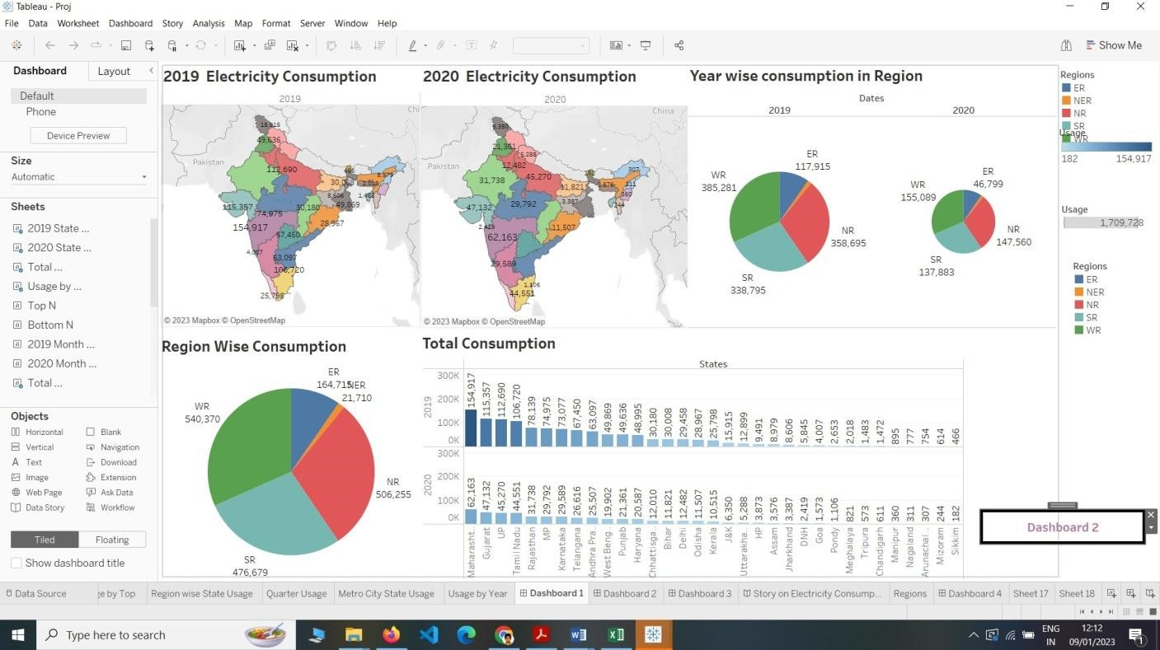

# Milestone 6: Story

A data story is a way of presenting data and analysis in a narrative format, with the goal of making the information more engaging and easier to understand. A data story typically includes a clear introduction that sets the stage and explains the context for the data, a body that presents the data and analysis in a logical and systematic way, and a conclusion that summarizes the key findings and highlights their implications. Data stories can be told using a variety of mediums, such as reports, presentations, interactive visualizations, and videos.

**Activity:1- No of Scenes of Story**

The number of scenes in a storyboard for a data visualization analysis of the electricity consumption in india will depend on the complexity of the analysis and the specific insights that are trying to be conveyed. A storyboard is a visual

representation of the data analysis process and it breaks down the analysis into a series of steps or scenes.

**Explanation video link:**

[**https://drive.google.com/file/d/1-RN0Yk5sbKqfakEJkgMHcn9WuoG9O8pa/view?usp=share_link**](https://drive.google.com/file/d/1RN0Yk5sbKqfakEJkgMHcn9WuoG9O8pa/view?usp=share_link)

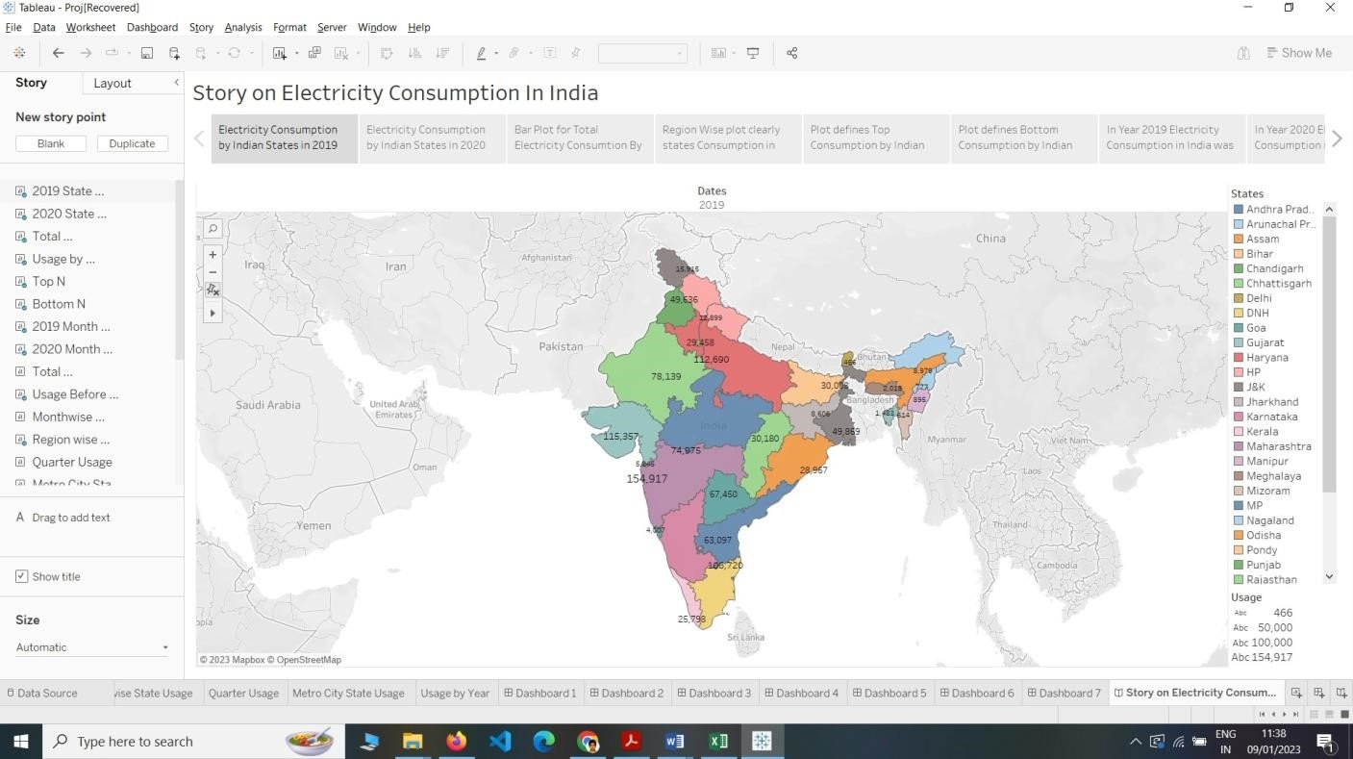

## Milestone 7: Performance Testing

### Activity 1: Amount of Data Rendered to DB

* The amount of data that is rendered to a database depends on the size of the dataset and the capacity of the database to store and retrieve data.

* Open the MySQL Workbench, go to the database then click to expand the tables,select the table and click on (i) button to get the information related to table such as column count,table rows

### Activity 2: Utilization of Data Filters

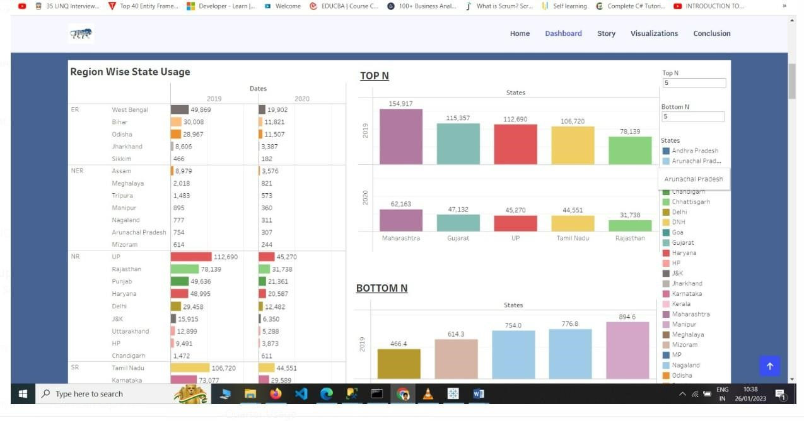

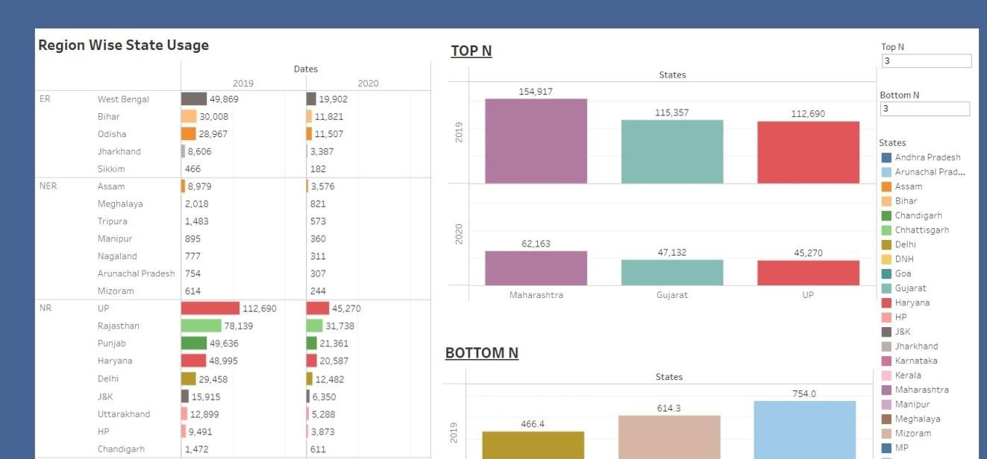

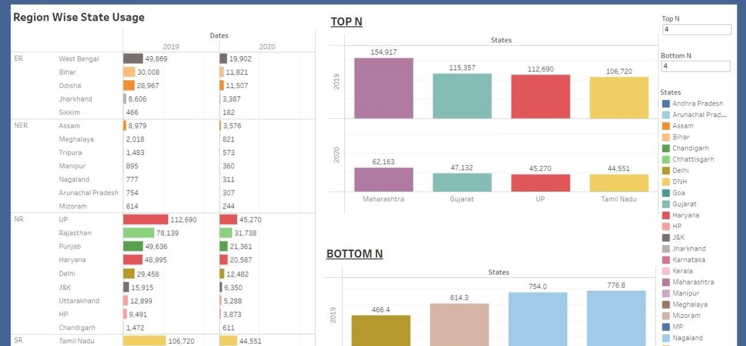

### Activity 4: No of Visualizations/ Graphs

1. 2019 State Consumption
2. 2020 State Consumption
3. Total Consumption
4. Usage By Region
5. Top N and Bottom N
6. 2019 and 2020 Monthwise Consumption
7. Total Consumption Region Wise
8. Usage Before and After Lokdown
9. Region wise State Usage
10. Quarter Usage
11. Metro city State usage
12. Usage by year

13.

## Milestone 8: Web integration

Publishing helps us to track and monitor key performance metrics, to communicate results and progress. help a publisher stay informed, make better decisions, and communicate their performance to others.

**Publishing dashboard and reports to tableau public**

Step 1: Go to Dashboard/story, click on share button on the top ribbon

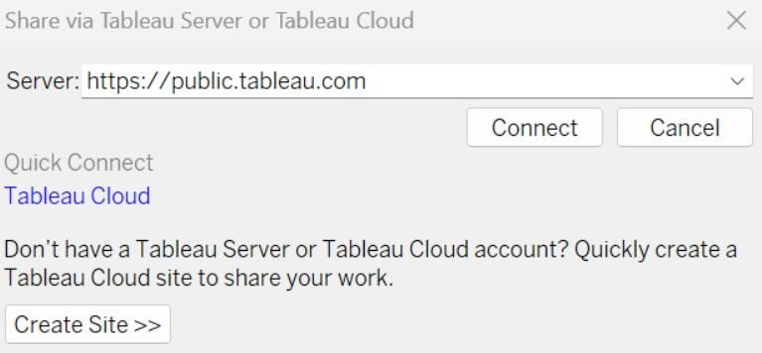

**Step 2:** Once you click on connect it will ask you for tableau public user name and password

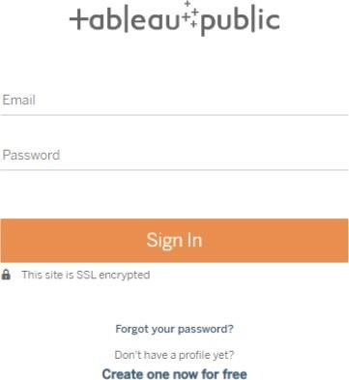

Once you login into your tableau public using the credentials, the particular visualization will be published into tableau public

**Note: While publishing the visualization to the public, the respective sheet will get published when you click on share option.**

### Activity 1: Dashboard and Story embed with UI With Flask

**Explanation video link:**

[**https://drive.google.com/file/d/1-RN0Yk5sbKqfakEJkgMHcn9WuoG9O8pa/view?usp=share_link**](https://drive.google.com/file/d/1-RN0Yk5sbKqfakEJkgMHcn9WuoG9O8pa/view?usp=share_link)

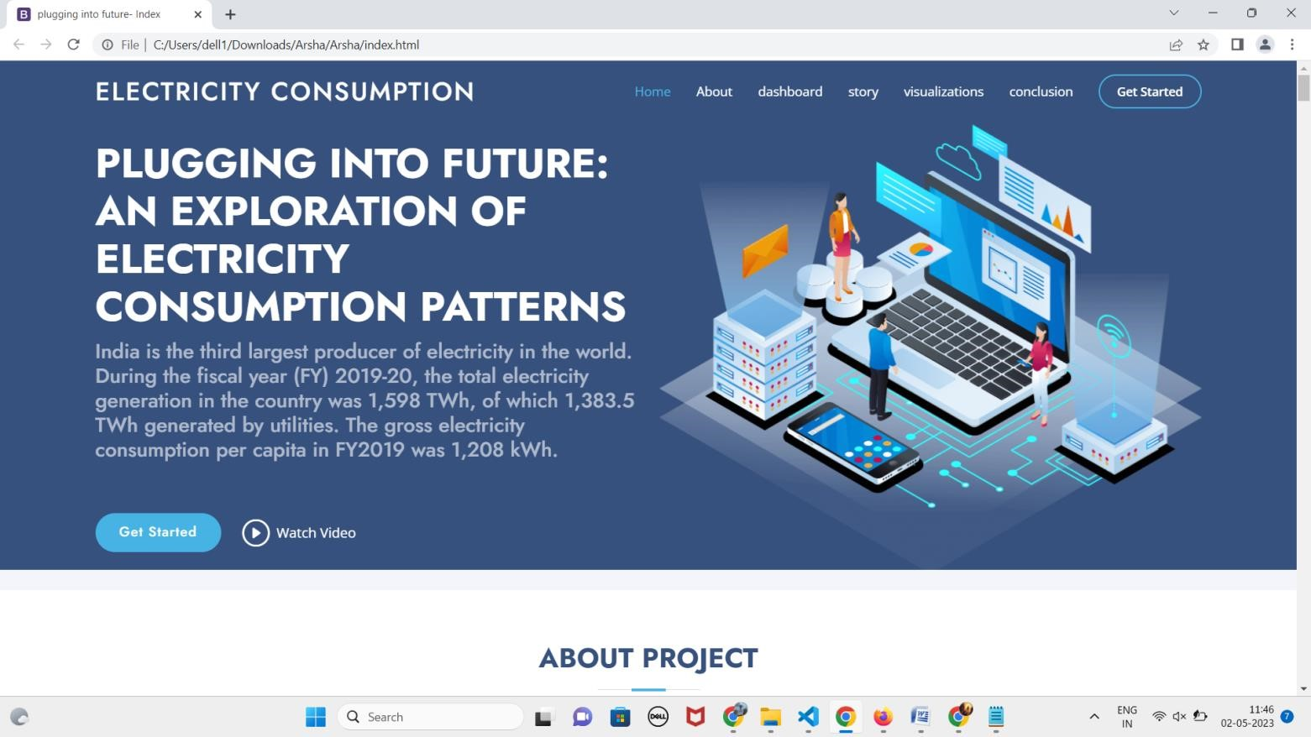

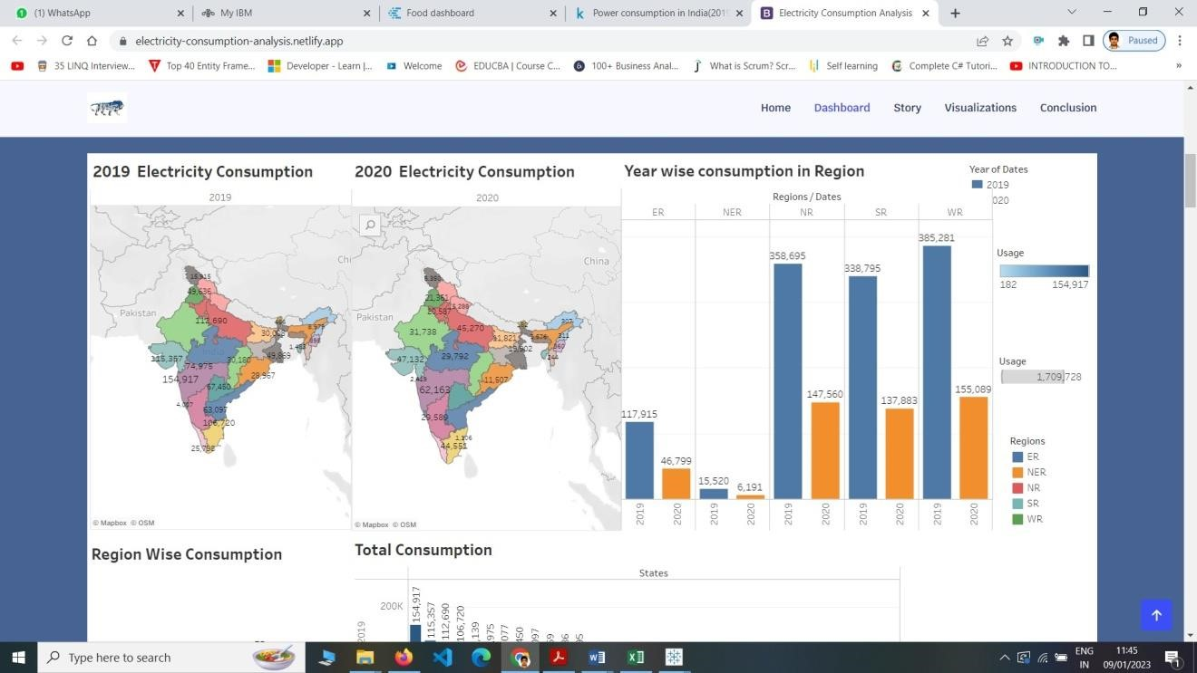

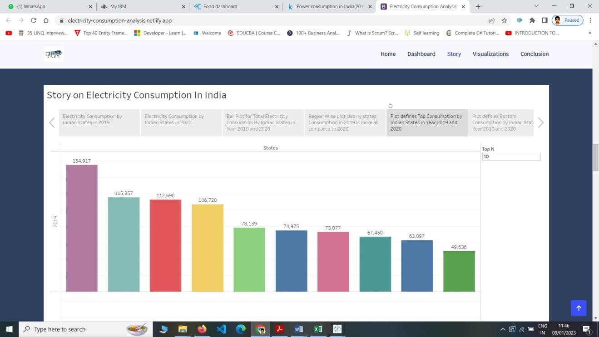

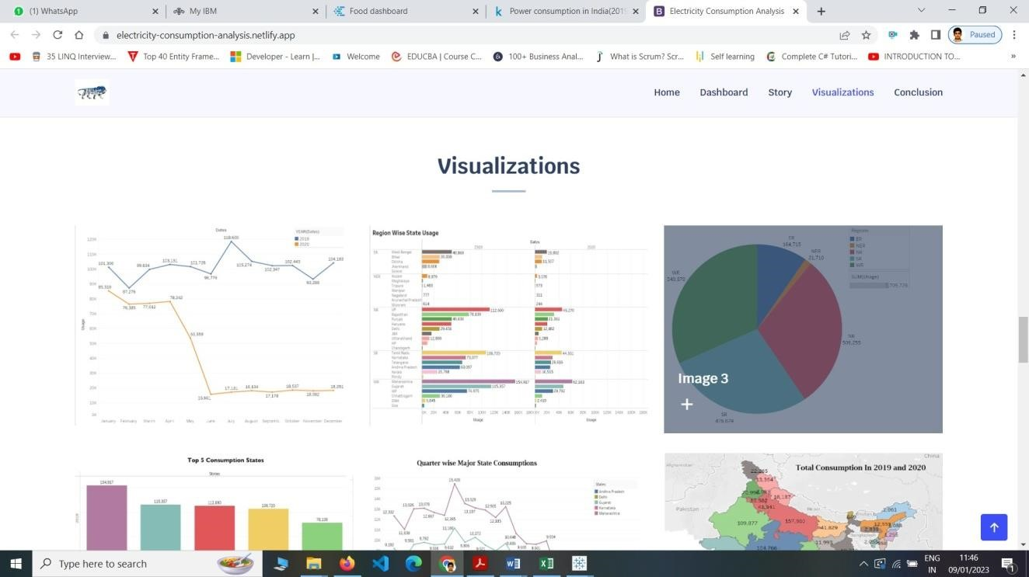

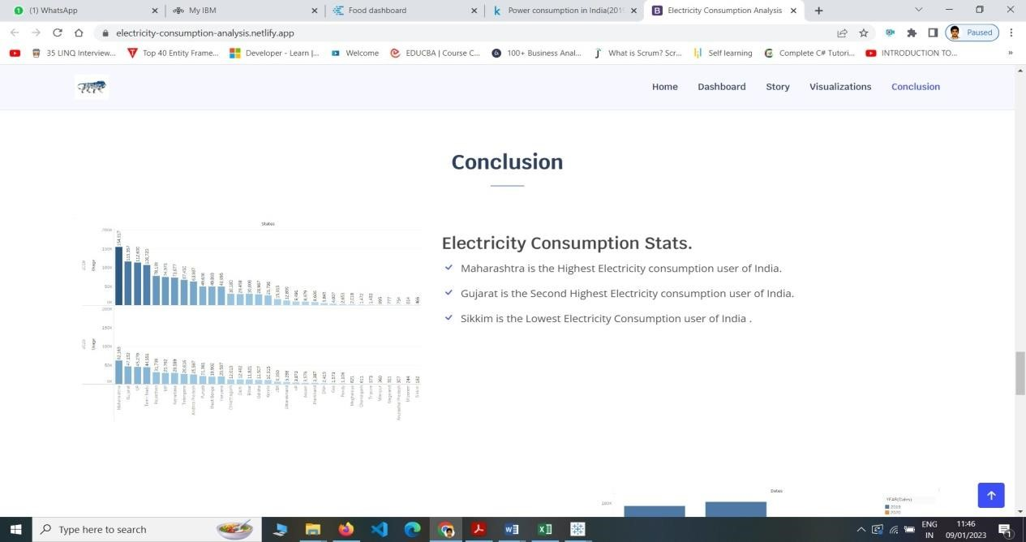

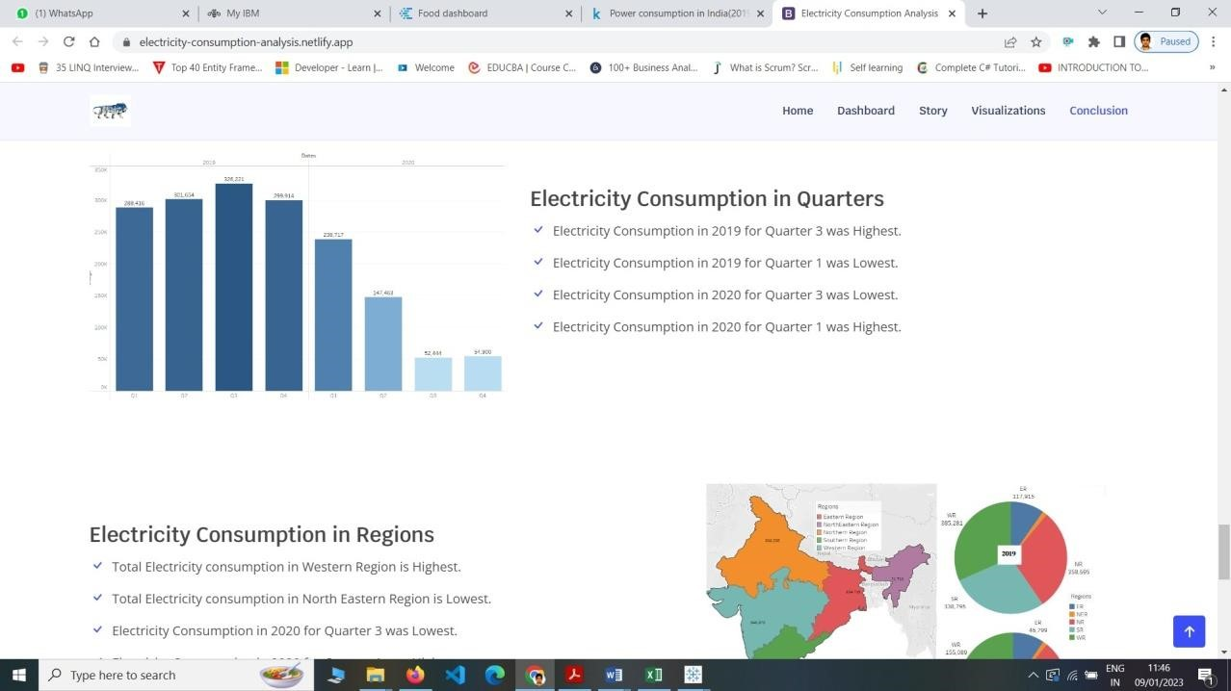

## Milestone 9: Project Demonstration & Documentation

Below mentioned deliverables to be submitted along with other deliverables

### Activity 1:- Record explanation Video for project end to end solution Activity 2:- Project Documentation-Step by step project development procedure

Create document as per the template provided